Project 1A | Password Checker

Design, implement and test a Java application that will validate passwords. For this project, a valid password is defined as –
- 6 or more characters (long). Each password must include -
  - 1+ numeric character
  - 1+ uppercase alphabetic character
  - 1+ lowercase alphabetic character
  - 1+ special character
  - No more than 2 of the same character in a sequence
- Strong password if it has 10 or more characters
- Weak password if its length is between 6 and 9 characters, however, it is a valid password
Here are some password examples –
Hello1@23 – Valid password
AAAbb@123 – NOT valid
Aaabbaa@123 – Valid (‘a’ and ‘A’ are NOT the same character)

Academic Honesty Policy Reminder – Do your own work – each submitted project will be compared against other submissions from current and previous semesters.

Good Faith Attempt (GFA) Requirement – Your submission must successfully pass all of the provided (public) Junit test cases. In general, they are the xyz_test.java and xyz_GFA_test.java files (where xyz is the project name). For Project 1 –
- PasswordChecker_GFA_Test.java
- PasswordCheckerTestPublic.java
- Others (if I have overlooked them)
- Include your test cases as specified in the PasswordCheckerTest_STUDENT.java

Expectations
- INCLUDE your name as the author on every Java file that you are creating
- When the application begins, the user will be presented with a screen that states the above instructions for creating a password, two text entry boxes for typing in a password, and three buttons. (See provided sample runs)
- If the user wants to check a single password, they will type in the password in both boxes and select the “Check Password” button
- If the user wants to read in and check a list of passwords, they will select the “Check Passwords in File” button, be presented with a file explorer, and select the file to read from. Those passwords that failed the check will be displayed, with their error message
Specifications
Data Element
- String

Data Structure
- ArrayList of Strings

Requirements
- Implement a PasswordCheckerUtility class as specified (See provided Javadoc)
- Create an exception class for each of the exceptions listed (see Javadoc)
- Always check for the length of a password first (it is the easiest and fastest check)
- STOP as soon as a password fails one rule, there is no need to check for the remaining rules
- You will need to implement a good number of the methods as follow -
- return a value under normal processing; otherwise, throw an exception
Here is an example -
/** * Checks the password Digit requirement - Password must contain a numeric character
* @param password - password string to be checked for Digit requirement
* @return true if meet Digit requirement
* @throws NoDigitException thrown if does not meet Digit requirement
*/
public static boolean hasDigit(String password) throws NoDigitException {
// your logic
}

As the method is being called with a password as its argument, the method will
return True // because the password has a digit in it
throw NoDigitException // otherwise
Do this for all methods with the same signature

- To check for a special symbol, use the following “regular expression” construct if you like. Check the whole password, and not just an individual character:
Pattern pattern = Pattern.compile("[a-zA-Z0-9]*");
Matcher matcher = pattern.matcher(str);
return (!matcher.matches());
- You will need to import Pattern and Matcher
- The following is the list of acceptable special characters for a password
  - !"#$%&'()*+,-./:;<=>?@[\]^_`{|}~
  - https://owasp.org/www-community/password-special-characters#:~:text=Password%20special%20characters%20is%20a%20selection%20of%20punctuation,and%20applications%20may%20apply%20limitations%20to%20this%20set%3A
- Here are a few helpful “regular expression” resources
  - https://www.vogella.com/tutorials/JavaRegularExpressions/article.html
  - https://www.youtube.com/watch?v=rhzKDrUiJVk
  - https://www.youtube.com/watch?v=sCuOJ8uadOg
- Test cases and test results (See Project Rubric)
- Test your project with a minimum of 4 test cases to ensure that your project is working correctly
- Capture your test runs (actual vs. expected results) in your write-up
  - This is to indicate that you have tested your project. A 28% deduction will be imposed to any project that did not include student test cases and their respective test results
- Testing your code is very important

The GUI (Use it to Test Your Project)
Use the provided GUI to test your code, and ensure that the GUI will –
- Inform the user if an entered password dose not match the re-typed password
- Use PasswordCheckerUtility methods to check validity of one password when user clicks on “Check Password” button.
- Use PasswordCheckerUtility methods to check validity a file of passwords when user clicks on “Check Passwords in File” button.
- Use a FileChooser for the user to select the input file.
- Use try/catch structure to catch exceptions thrown by PasswordCheckerUtility methods

The provided GUI should work as-is to support your testing. Even if it’s off by a little, such as the special character expectation is not captured on the UI (or other issues that we have not yet encountered), you still can use it to test out your logics. The magic that enforce all of the requirements are implemented by the PasswordCheckUtility. Consult with your instructor first, if you are thinking about making changes to the GUI – there is no reason to.

As a student, I would -
- Implement all requirements (methods) for the PasswordCheckerUtility.java file
- Create all defined exceptions
- Pass all provided JUnit test cases
- Test your code using the provide UI
- Anticipate private test cases

As I (Instructor) grade each project submission, I will make UI updates accordingly if needed. Don’t spend too much time fixing any UI related code. The UI will work with the requirements that I have specified.
- Should you encounter any JavaFX import errors, check out the following article
  - https://www.chrisnewland.com/eclipse-cant-find-import-javafx-320
- You MUST fix all JavaFX errors so that you can test your project with the provided GUI
- If you did not complete CMSC 203 at MC or it has been a while since you took the course, you may need to download JavaFX
  - https://www.youtube.com/watch?v=oVn6_2KuYbM
  - https://gluonhq.com/products/javafx/

Exceptions
Create corresponding classes for each exception listed in PasswordCheckerUtility Javadoc:
- Class LengthException:
  - Length of password is less than 6 characters
  - Output Message – The password must be at least 6 characters long
  - Create all of your exception classes similar to the provided LengthException.java
- Class NoUpperAlphaException
  - Password doesn’t contain an uppercase alpha character
  - Message – The password must contain at least one uppercase alphabetic character
- Class NoLowerAlphaException
  - Password doesn’t contain a lowercase alpha character
  - Message – The password must contain at least one lowercase alphabetic character
- Class NoDigitException
  - Password doesn’t contain a numeric character
  - Message – The password must contain at least one digit
- Class NoSpecialCharacterException
  - Password doesn’t contain a special character
  - Message – The password must contain at least one special character
- Class InvalidSequenceException
  - Password contains more than 2 of the same character in sequence
  - Message – The password cannot contain more than two of the same character in sequence
- Class WeakPasswordException
  - Password contains 6 to 9 characters which are otherwise valid
  - Message – The password is OK but weak - it contains fewer than 10 characters
- Class UnmatchedException
  - Password and re-typed Password are not identical
  - Message – The passwords do not match

Throw your exception according to the above order. For example, if a password is “xxyyzzwwaa$”, it fails rules 2 and 4 above. Throw a NoUpperAlphaException, but not a NoDigitException

Testing and Student JUnit Test Cases
- Complete the Junit test cases in the provided PasswordCheckerTest_STUDENT.java file
- Ensure that your project can successfully pass all of the (other) provided public test cases
- Confirm with your instructor first if you need to modify any provided Java files (except for the package references.) Your instructor will use the original (provided) test cases during grading.
- Your instructor will grade your project by (1) testing it against an additional set of public and private test cases, (2) running your code against the UI.
- Thoroughly test your project
- Except for the package references (but not the classes), you should not need to modify any of the provided Java files. Check with the Instructor first if you must, as your instructor will “use” the original Java files – not yours.

Programming Concepts
This project utilizes the following concepts:
- ArrayList
- Read Files
- Javadoc
- JUnit Tests
- Exceptions

Write-up & Submission Requirements
Review the provided rubric to understand the project expectations, including documentation, CMSC204 and programming requirements. Each project submission MUST include your working Java code and a write-up. For Project 1, a sample write-up has been provided.

Your write-up, at a minimum, needs to address -
- Approach, design & algorithm
  - DO NOT start coding your project immediately! Come up with a high level design first. Complete this step first, then write your code
    - Break the project into smallest modules where applicable
  - Each student is welcome to expand on the design. If your project includes “above and beyond” features, clearly articulate them in your write-up. Potential extra credit could be earned if that is the case
- Test plan & test cases
  - What test cases did you run?
  - I want to understanding your “thinking,” and you need to be sure that your project works!
  - For each test case, specify the expected vs. actual outputs
  - Capture several test runs as screenshots, as you run your test cases
  - I will attempt to break your code (with reasonable test cases)
- Highlight your learning experience and lessons learned
  - I am very interested to learn about what you have done, how you did, etc.
- Discuss any additional enhancement
  - What did you do?
- Any assumptions that you are making for this project
- Anything else that you want to share

Each student must submit one compressed (.zip) file back to the Assignment (link) with the following:
- Source code (.java files)
- Write-up (a Word or PDF file)
- Name your compressed file as <lastname>_project_x
  - where x is the project number and your last name (e.g., Thai_Project_1.zip)
- Review provided instructions on how to submit the project carefully (don’t assume anything)
- I can only grade what’s being submitted. Double check your submission
- I MUST BE able to compile, run and test every submitted project on my computer using a set of test cases. Just as important, I will READ your write-up first

Not clear? That’s okay, but do ask your questions. “I did not know” or “I did not understand” is not good enough.

Start working on each project immediately so that we can discuss any concerns or questions you have.

File Format
If you select the “Check Passwords in File” button, you will be presented with a file chooser. You must navigate to where you stored the file “passwords.txt” and load it. The file will be in the following format (one password per line):

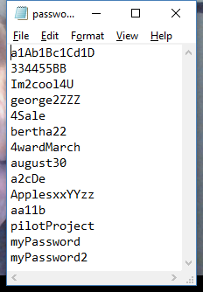

Sample Test Cases & Outputs (Consider them as examples only)

These are sample test runs (only)! They are provided to give you an “understanding” about the project. Your actual runs could / will be different!

At start-up, the UI looks something like these provided screen shots –

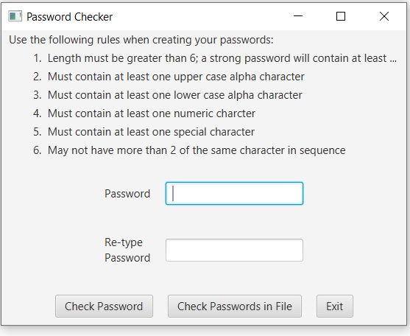

- No lowercase alphabetic character (This screenshot is from last semester)

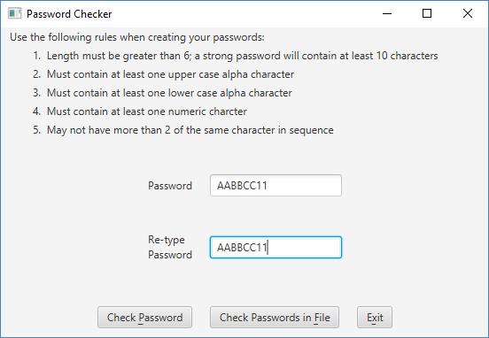

Displayed to the user:
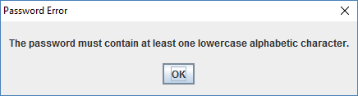

- No digit

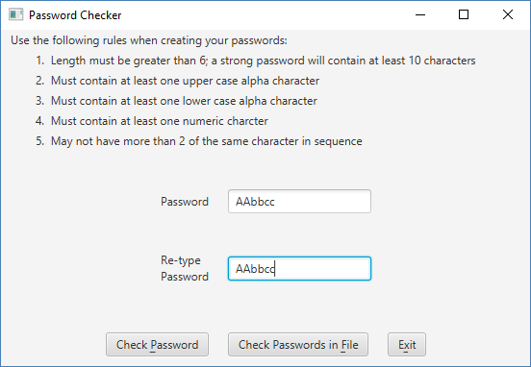

Displayed to user:

- If the password is OK, but between 6 and 10 characters, you will see:

- If password has more than two of the same characters in a row
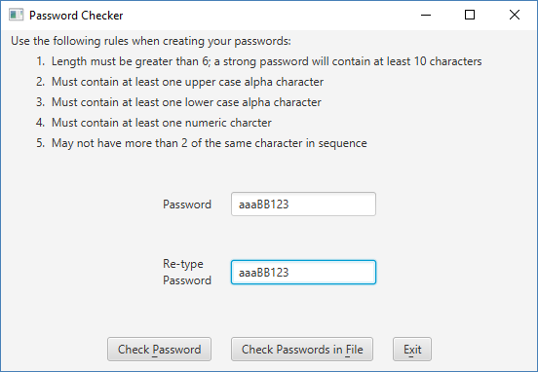

Displayed to user:
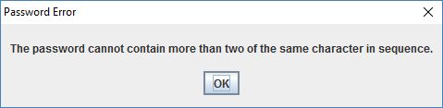

- If password is valid
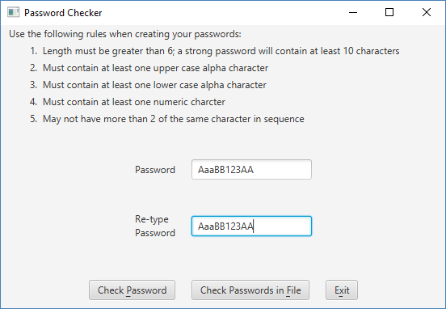

Displayed to user:
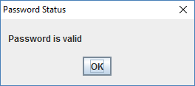

If the passwords do not match:
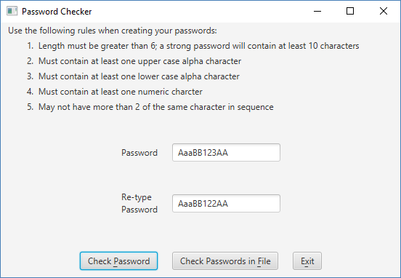

Displayed to user:
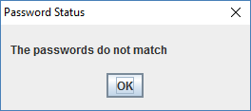

Don’t forget to think about those private test cases that your instructor will be testing your project against.

